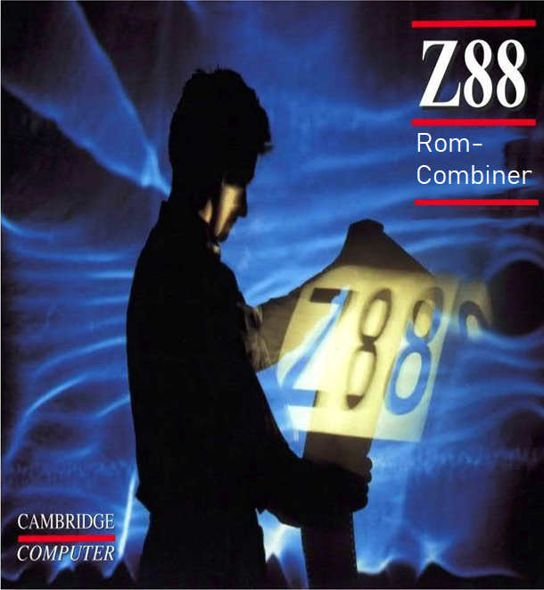

RomCombiner v2.02

(c) Garry Lancaster, 2000-2005

[ Flash Card programming (c) Thierry Peycru, Gunther Strube ]

# Introduction

RomCombiner is a BASIC program which allows you to combine several ROM

images onto a single card, thus enabling you to use many applications

from a single large (eg 128K or 256K) ROM, instead of having to

continually swap cards. With the new Flash Cards, you could fit just

about every application ever written for the Z88 onto a single card!

Another feature of RomCombiner is that it allows you to modify the

letter key assigned to a particular application, change an

application's name, alter the order that applications appear in the

Index, or even leave out an unwanted application from the Index.

The program also includes facilites for reading ROM images, and for

programming standard EPROMs and Flash Cards, and erasing Flash Cards.

The latest version of RomCombiner and other free Z88 software is always

available from the Z88 Forever! website.

Content

Introduction 3

Using the program 5

Read ROM card to image files 5

Combine image files of cards 6

Key 6

Order 7

Rename 7

Patch 7

Info 8

Disp 8

Wait 9

Techy 10

Save 10

Load 10

Create 11

Quit 11

Verify EPROM banks properly erased 12

Blow image files to blank EPROM 13

Flash Card block erase 14

Compatible flash chips 15

Emulator file conversion 16

Adding an EPROM filing system to your card 17

Known problems 19

# Using the program

RomCombiner is a collection of three files: 'romcombiner.bas',

'romutil.bas' and 'romcombiner.bin'. Load all three files into your

Z88 in the same directory, start a BBC BASIC application with #B and

RUN "ROMCOMBINER.BAS".

The main menu provides eight options, allowing you to create image

files from a ROM in the Z88, combine one or more sets of images, and

program a blank EPROM with a set of images. You can also check EPROMs

are properly erased, convert emulator files, erase Flash Cards, change

the "wait" mode, and exit the program.

# Read ROM card to image files

Upon selecting this option, you are asked for the slot containing the

ROM you want to make image files from, and a name for the card (this

can be up to 12 characters long).

Usually, you should type "F" to create images of the full ROM card; in

this case, the program will detect the size of the card and create the

appropriate number of images. For example, if you have the PCLink 2 ROM

in slot 2 and answered "2" for the slot number and "pclink" for the

card name, the program will create images called pclink.63 and

pclink.62.

Advanced users may like to choose to take an image of a single bank, or

range of banks, from a card.

# Combine image files of cards

When you have got all the images of the cards you wish to combine,

select the "combine" option. This presents you with a further menu

of choices.

The first thing to do is Add a card to the ROM you are creating: just

enter A and you will then be asked for the name of a card to add. This

should be entered without an extension - for example, if your images

are called pclink.63 and pclink.62, you should just enter pclink.

After successfully adding a card, the display will show the total

number of cards, applications and the total ROM size of the new card.

As well as this, there is some information about each application

found. Example:

2. L=PCLink (4)

This shows that PCLink is application number 2, and will be accessed

with key L. The number in brackets shows the order that the application

will appear in the Index list (ie. 4th on this card).

At this point you can add further cards, or alter the details of the

applications loaded so far.

## Key

This option lets you specify a different letter for the application to

be called by. This is useful if you have several applications using the

same key. If, for example, you had three applications using key W, then

only the first would be accessed with []W, the second with []ZW and the

third with []ZZW. So, it might be better to assign an unused letter to

one of the applications.

You can also choose 0 in this option, in which case the application

will not be given a hotkey, but must be selected from the Index menu.

## Order

This lets you change the order of the application list in the Index.

You can enter an application number and a new position for it (entering

0 for the position will leave it out of the application list

altogether).

Alternatively, press ENTER, and then enter the numbers of the

applications in the order you wish them to appear in the Index. Press

ENTER again when you've listed all the applications you want; any you

have not specified will be left out of the Index list.

Leaving applications out of the Index list can be useful if there is an

application you never need present on one of your cards (for example,

Diskfiler 2 if you do not have a disk drive!). However, note that doing

this does not actually save any space on the new card.

## Rename

This lets you change the name of an application. The new name must

be the same length or shorter than the original one.

## Patch

Some applications are written expecting to be located in specific

banks in a certain-sized cards, and do not usually work correctly after

being "combined" into a larger card. This option allows you to select a

patch file designed to correct this behavior for a particular

application, and so allow it to be used in combined cards.

If you find an application which does not work properly in a combined

card, you should check if a patch file is available for it. Some patch

files are included with this release of RomCombiner, but there may be

others available. These can always be obtained from the Z88 Forever!

website.

To use a patch, simply use this option and type in its filename. The

patch will then be applied during generation of the new card. Any

application which has a patch assigned to it is marked with an asterisk

(*) in the list. To remove a patch from an application, just press

ENTER when asked for the filename.

When combining a card with a patch, you may see some warnings displayed.

This could mean you have the wrong patch selected for the application (in

which case the application probably won't work correctly). However, it's

more likely that the application has been patched previously when combined

into another card - in this case the warnings can be ignored.

## Info

This displays technical information on the selected application for

advanced users.

## Disp

This toggles the display mode. When on, you will always see a list of

the current applications on the combined card. However, if this list

becomes too long, you may prefer to turn it off with this option.

## Wait

This toggles the wait mode (you can also do this from the main menu).

If "Wait mode" is on, the program will tell you whenever it needs to

load a new image file, and whenever it has saved an amended copy of an

image file. This is useful if you do not have enough memory on your Z88

to hold all the ROM images at once; at these pauses you can transfer

files between the Z88 and another computer, ensuring that the program

always has access to the files it needs.

## Techy

Another set of options for advanced users. They allow you to:

1. Alter the ID of the card being created

2. Set the last application to point to another bank and address,

instead of an end-of-list marker

3. Force the card to have a particular size, instead of the calculated one

4. Create images starting from a bank other than 63

5. Enable an EPROM filing system on the card (see later for details)

The main use for these options is to allow you to create very large ROM

cards in two or more stages, without having to set the wait mode on.

## Save

This option saves all the details of the ROM you are currently

creating. This is useful when you are making a lot of changes or adding

a lot of cards, since if something goes wrong you can simply re-start

the program and Load the configuration up again. You might also like

to save the configuration of a ROM you are creating, so that if you

want to make changes at a later date you don't have to start from

scratch.

## Load

Re-loads a previously saved configuration.

## Create

Once you have added all the cards you require, and are satisfied with

the application list, press C to finish and create the final images.

First enter a name for the new card (again with no extension). This

will be used to create images called CARDNAME.63 etc. down to the lowest

bank in the card.

Unless you have lots of free memory, you should answer Y to the next

question; this deletes the original images as it creates the new ones,

to preserve memory.

Then the program will create the new card images. This can take a long

time!

## Quit

This aborts the combination process and returns you to the main menu.

# Verify EPROM banks properly erased

If you're unsure whether your EPROMs are being properly erased (perhaps

you have problems blowing ROMs to them), this option allows you to

check whether they are ready to program.

Usually, you should press F to check a full EPROM, and enter the size of

the card. Alternatively, you can enter a range of banks; use the same

number for both if you only want to check one bank.

If you do have problems with EPROMs that you can't seem to erase, try

tapping the card sharply on a hard surface and then re-erase it. This

will dislodge any particles which may be on the window and preventing

the UV light from reaching the chip.

# Blow image files to blank EPROM

This main menu option allows you to create a ROM on a totally blank

EPROM in slot 3 (it must not have been catalogued by Filer).

After entering the EPROM type and the card name, press F to

automatically blow all the images in the card. Once this is completed,

you should go to the Index, remove the card, close the flap and then

re-insert the card again to properly initialise the application list.

Advanced users can choose to blow a range of banks to the EPROM.

Note that this option will refuse to write any bytes if the batteries

are low, to ensure EPROM integrity.

# Flash Card block erase

This option allows you to erase blocks of your Flash Cards (in slot

3), either individually or all at once.

Enter the block number (1-16 for 1Mb Flash Cards) or 256 to erase the

entire card.

Each "block" is the smallest unit of a Flash Card which can be erased,

and consists of 4x16K banks. They are arranged as follows:

Block Banks

1 0 to 3

2 4 to 7

3 8 to 11

4 12 to 15

5 16 to 19

6 20 to 23

7 24 to 27

8 28 to 31

9 32 to 35

10 36 to 39

11 40 to 43

12 44 to 47

13 48 to 51

14 52 to 55

15 56 to 59

16 60 to 63

## Compatible flash chips

I28F004S (512K)

I28F008S5 (1Mb)

AM29F010B (128K)

AM29F040B (512K)

AM29F080B (1Mb)

AMIC29F040B (512K)

# Emulator file conversion

This option allows you to convert between the bank files used within

this program (eg. name.62, name.63 etc.) and the “name.epr” files used by

the Z88 emulators.

Simply enter the name of a file to convert (without any extension). If

an .EPR file of that name is found, it will be converted to individual

bank files which can be worked on by this program. If a .63 file of the

name given is found instead, then a .EPR file will be created, which

can be used by Z88 emulators.

# Adding an EPROM filing system to your card

It is now possible to add files to your application cards. This is not

an automatic process, but it is well worth the effort to create a card

containing both your favorite applications and most important

non-changing files (such as BASIC programs that you always require).

If you have a Flash Card, do *not* follow this procedure. It is much

easier to create a ROM on the Flash card in the normal way, and then use

FlashStore to format the remaining space for use with files. This also

gives much more flexibility, as you can save files at any time, and even

re-format the file area.

If you wish to add files to an ordinary 128K or 256K EPROM, however, this

is the only way to do it...

Files can only be added to the card during the creation process; there

is no way to save additional files. In addition, the Filer and other

EPROM-handling programs cannot read files from these special combined

ROM/EPROM cards.

There is a modified version of the EP-Fetch application now available

on the Z88 Forever application card which can handle reading of files

from any EPROM (including Flash Cards) or ROM/EPROM card in any slot

of the Z88. I suggest that you include the Z88 Forever card in any

combined card you make, so that you can always retrieve files from it.

There are several stages to adding files to your card:

1. Save the files you require to an ordinary (blank) EPROM.

2. Work out how many banks of your EPROM are in use. This can be done

by dividing the size reported by EP-Fetch by 16384 and rounding up.

eg. If EP-Fetch reports 26712 bytes used, then 26712/16384=1.63

Therefore, 2 banks are in use.

3. Use the [R]ead option to read the required banks from the EPROM

card. The banks you need are numbered upwards from 0. For example,

if 5 banks are in use you would read banks 0 to 4.

4. Use the [B]low option to blow these banks to your new card.

5. Use the [C]ombine option to generate the ROM images you need.

Before selecting [C]reate, use the [T]echy options and set the

EPROM filing system option.

6. Finally, [B]low the ROM images to your card.

Don't forget that the size of your ROM images plus the size of your

EPROM files cannot exceed the total physical card size!

# Known problems

You should be careful not to use your new combined ROM at the same time

as the original ROMs. This is because the new ROM will have the same ID

as the first card that you entered, and this sort of thing confuses OZ

no end! To avoid this, you could alter the Card ID (in [T]echy options)

manually.

If you find an application that does not work as expected in a combined

card, there are three main courses of action you can take:

1. Check if a patch file is available for the application

2. Try re-creating the ROM, with the problem application as the first

card to be added to the ROM

3. Contact me to discuss a possible solution

Finally, application cards cannot use bank 0, as the Z88 operating

system uses this value to signify "no bank". Thus the largest possible

application card is 1008K (using banks 1 to 63).

Garry Lancaster, 4th July 2000

